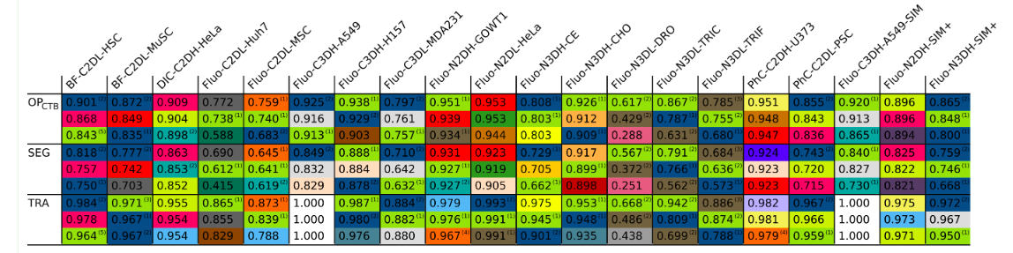

Fluo-C2DL-MSC

* SEG score - 0.645 (2nd least) , TRA score - 0.873 (3rd least)
* Two sequences of 48 frames each
* **Very Low SNR and CR values**
* Shape of cells is very irregular (very different from circular) due to **long, thin extensions** which also cause the cell boundaries to be very vague (not well defined). Thus, **segmentation is difficult**.
* Shape of cells changes significantly even within consecutive frames.

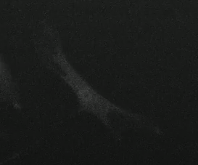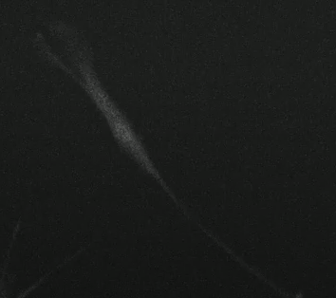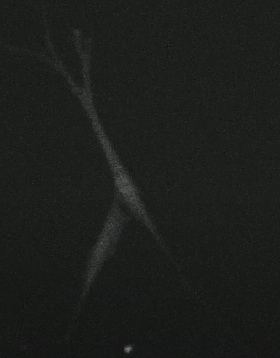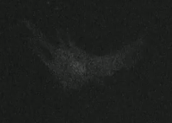

* Significant fading is present as intensity in some of the cells is higher than others

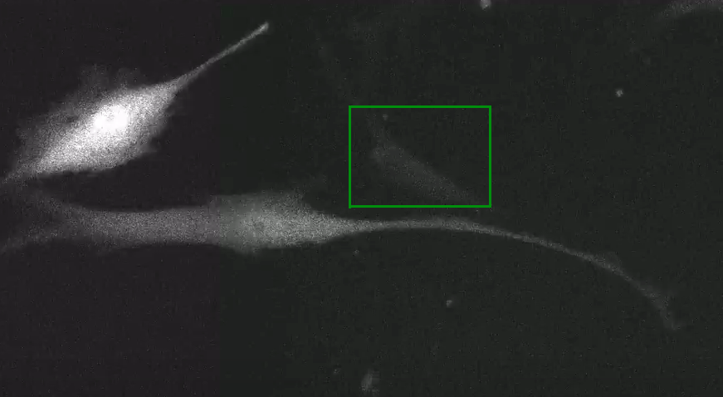

* Cells move fast causing **low overlaps between cells of consecutive frames** thus **tracking is difficult**
* No cell divisions are present.

Fluo-C2DL-huh7

1. SEG score - 0.690 (3rd least) , TRA score - 0.865 (2nd least)
2. Two sequences of 30 frames each.
3. **SNR and CR values are much higher** than C2DL-MSC dataset.
4. Cluster of cells are present.
5. **Sequence 01 :**

* Very **less movement** in cells between consecutive frames so tracking score is low maybe due to the presence of **clusters of cells**.
* Most of the cells have a regular (circular-like) shape.
* **Intra-cellular heterogeneity** is present so cell over-segmentation may occur thus, SEG score is low.  
  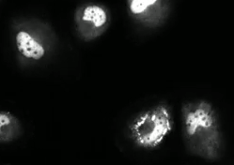
* Cell divisions are present

1. **Sequence 02**:

* Most of the cells have very little movement between consecutive frames. But very few cells have fast movement so tracking these will be more difficult than others.
* Intra-cellular heterogeneity is present.
* Cell divisions are present.
* One of the cells undergoes very rapid shape variations unlike the other cells.  
  